|  |  |
| --- | --- |
| **TIẾNG ANH 6 FRIENDS PLUS** | **Final Second term - Test 2**  *Thời gian làm bài: 45 phút (Không kể thời gian giao đề)*  *-------------------------* |

**I. Pronunciation**

**Câu 1.** Which word has the underlined part pronounced differently from that of the others?

**A.** cable  **B.** avatar  **C.** far  **D.** car

**Câu 2.** Which word has the underlined part pronounced differently from that of the others?

**A.** try  **B.** probably  **C.** exactly  **D.** sunny

**Câu 3.** Which word has a different stress pattern from that of the others?

**A.** comment  **B.** picture  **C.** balloon  **D.** landscape

**Câu 4.** Which word has a different stress pattern from that of the others?

**A.** extreme  **B.** Antarctica

**C.** weather  **D.** around

**II. Choose the answer (A, B, C or D) that best fits the space in each question.**

**Câu 5.** If it _____ tomorrow, we _____ at home.

**A.** rained / stayed  **B.** rains / stayed

**C.** will rain / will stay  **D.** rains / will stay

**Câu 6.** What will you do if you have a day off?

**A.** I watched that film. It was great.

**B.** Yes, my company has a day off tomorrow.

**C.** I will go hiking and spend time in nature.

**D.** I will give you my e-mail soon.

**Câu 7.** Yesterday, I _____ the house.

**A.** clean  **B.** will clean

**C.** cleaning  **D.** cleaned

**Câu 8.** If I _____ enough money, I _____ a new car.

**A.** had / bought  **B.** will have / will buy

**C.** have / bought  **D.** have / will buy

**Câu 9.** Listen! I think there is someone ______ the front door.

**A.** with  **B.** at  **C.** on  **D.** in

**Câu 10.** The **________** travels at high speed through the galaxy.

**A.** plane  **B.** spaceship  **C.** boat  **D.** car

**Câu 11.** Did you go on vacation last weekend?

**A.** Yes, I like shopping with friends.  **B.** Yes, I love food.

**C.** No, I was too busy with my presentation.  **D.** No, my flight is about to take off.

**Câu 12.** I’ll call you ______ seven o’clock.

**A.** at  **B.** of  **C.** in  **D.** on

**Câu 13.** John is **_________** and he plays basketball.

**A.** blonde  **B.** straight  **C.** tall  **D.** dark

**Câu 14.** My sister is **__________**, but she sings really well.

**A.** curly  **B.** grey  **C.** short  **D.** spiky

**III. Look at the signs. Choose the best answer (A, B, C or D).**

**Câu 15.**

What does this note mean?

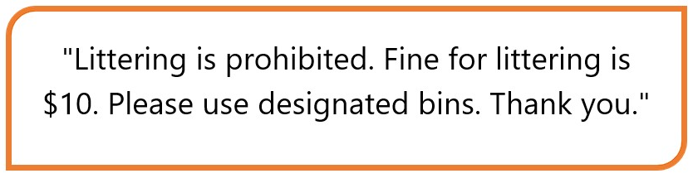

**A.** Littering is prohibited and violators will be fined $10.

**B.** Visitors can litter wherever they want.

**C.** Visitors are allowed to litter in this area.

**D.** Littering is allowed, but visitors must pay a $10 fine.

**Câu 16.**

What does this note mean?

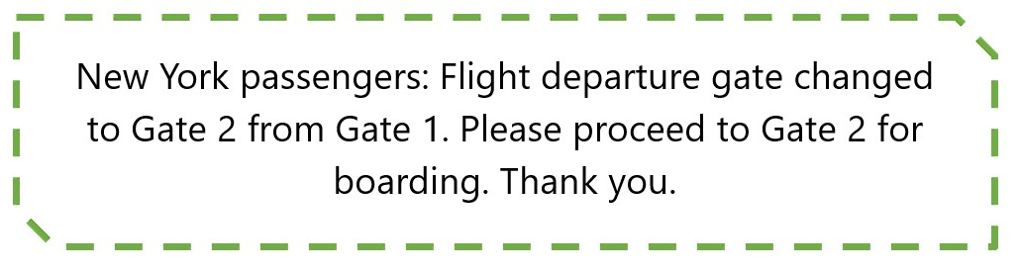

**A.** Passengers travelling to London should proceed to Gate 1.

**B.** Passengers should proceed to the gate immediately.

**C.** The departure gate for New York has been changed to Gate 2 from Gate 1.

**D.** The flight to New York has been cancelled.

**IV. Read the following passage and do as direct.**

Last summer, I took a trip to Nha Trang and it was amazing! The stunning beaches, warm weather, and delicious food made it a perfect holiday destination. I explored the local markets and found some great souvenirs to bring back home. Snorkeling in the ocean was the highlight of my trip as I saw some breathtaking sea creatures. Overall, Nha Trang was an unforgettable experience and I highly recommend it for anyone looking for a fun and relaxing vacation.

**Câu 17.** The writer took a trip to Nha Trang last summer.

**A.** False  **B.** True

**Câu 18.** The weather in Nha Trang was cold during the writer's trip.

**A.** True  **B.** False

**Câu 19.** The writer did not try any local cuisine while in Nha Trang.

**A.** True  **B.** False

**Câu 20.** Snorkeling was not one of the highlights of the writer's trip to Nha Trang.

**A.** True  **B.** False

**Câu 21.** What was one of the highlights of the writer's trip to Nha Trang?

**A.** Shopping at local markets  **B.** Snorkeling in the ocean

**C.** Eating at fancy restaurants  **D.** Visiting museums

**Câu 22.** What is the writer's overall recommendation for Nha Trang?

**A.** Good for a relaxing vacation  **B.** Not worth visiting

**C.** Only good for adventurous travelers  **D.** Best for budget travelers

**V. Choose the word (A, B, C or D) that best fits the blank space in the following passage.**

Dear Max,

I **____23____** this email finds you well. With the weather getting warmer, I thought it would be a great idea to plan a **___24_____** to the countryside. I would like to invite you to join me **____25____** a train trip to the beautiful countryside next weekend. We can **____26____** the scenic views and enjoy some fresh air away from the hustle and bustle of the city.

Let me know if you're **____27____**, and we can plan the details together. I am looking forward to **___28_____** back from you soon.

Best regards,

Paul.

**Câu 23.** Choose the correct answer.

**A.** like  **B.** hope  **C.** enjoy  **D.** want

**Câu 24.** Choose the correct answer.

**A.** concert  **B.** hike  **C.** trip  **D.** party

**Câu 25.** Choose the correct answer.

**A.** at  **B.** in  **C.** on  **D.** about

**Câu 26.** Choose the correct answer.

**A.** listen  **B.** smell  **C.** explore  **D.** hear

**Câu 27.** Choose the correct answer.

**A.** interested  **B.** bored

**C.** unwilling  **D.** sick

**Câu 28.** Choose the correct answer.

**A.** hearing  **B.** receive  **C.** getting  **D.** listen

**VI. Supply the correct form of the word given in each sentence.**

**Câu 29.** We are ____________ the train to go on vacation. [board]

**Câu 30.** She has ____________ hair that bounces when she walks. [curl]

**Câu 31.** My ____________ is that the home team will win the match today. [predict]

**Câu 32.** The weather looks ____________ for our picnic. [promise]

**Câu 33.** I am ____________ that I will succeed. [hope]

**Câu 34.** Let's go ____________ in the woods. [camp]

**VII. Rearrange the groups of words in a correct order to make complete sentences.**

**Câu 35.** along/stopped at/the route. /The tram/every station

_____________________________________________________________________

**Câu 36.** on stage/The famous/singer performed/her latest hit/last night.

_____________________________________________________________________

**VIII. Rewrite each of the following sentences in another way so that it means almost the same as the sentence printed before it.**

**Câu 37.** I will able to watch a movie with friends if I finish my work early today.

Unless I _____________________________________________

**Câu 38.** Mr. Kim cooks really well.

Mr. Kim is _____________________________________________

**Câu 39.** There were 1000 employees in this company last year.

This company consisted _____________________________________________

**Câu 40.** He was famous thanks to his invention.

His invention _____________________________________________

**----HẾT---**

| **Word** | **IPA** | **Word Class** | **Vietnamese Meanings** |
| --- | --- | --- | --- |
| Last summer | læst ˈsʌmər | n | mùa hè năm trước |
| Trip | trɪp | n | chuyến đi, du lịch |
| Nha Trang | nha træŋ | n proper | Nha Trang |
| Amazing | əˈmeɪzɪŋ | adj | tuyệt vời, kỳ diệu |
| Beaches | ˈbiːtʃɪz | n | bãi biển |
| Warm weather | wɔrm ˈwɛðər | n | thời tiết ấm áp |
| Delicious | dɪˈlɪʃəs | adj | ngon miệng |
| Souvenirs | ˌsuːvəˈnɪrz | n | hàng lưu niệm |
| Snorkeling | ˈsnɔrkəlɪŋ | n | lặn có ống thở |
| Sea creatures | si ˈkritʃərz | n | sinh vật dưới biển |
| Hope | hoʊp | v | hy vọng |
| Trip | trɪp | n | chuyến đi, du lịch |
| On | ɒn | prep/adv | trên, vào |
| Countryside | ˈkʌntrisaɪd | n | miền quê, nông thôn |
| Invite | ɪnˈvaɪt | v/n | mời gọi, lời mời |
| Enjoy | ɪnˈdʒɔɪ | v | thưởng thức, tận hưởng |
| Interested | ˈɪntrəstɪd | adj | quan tâm, muốn tham gia |
| Hearing | ˈhɪrɪŋ | n | việc nghe, tin tức |
| Train trip | treɪn trɪp | n | chuyến đi bằng tàu hỏa |
| Scenic views | ˈsiːnɪk vjuːz | n | cảnh quan đẹp |